Centre Admin OnScreen Theory Exam
Navigate to following URL:
http://www.itecworld.co.uk/itec/college/Login.aspx
College Admin role is required to Create/Print NVQ papers
Select Language as required from the drop down menu.
Enter your login details > Click Login
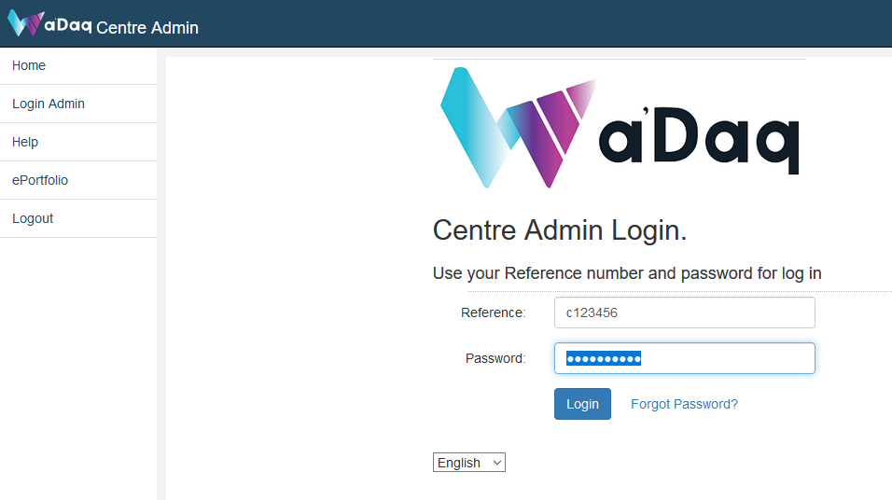

Select College.

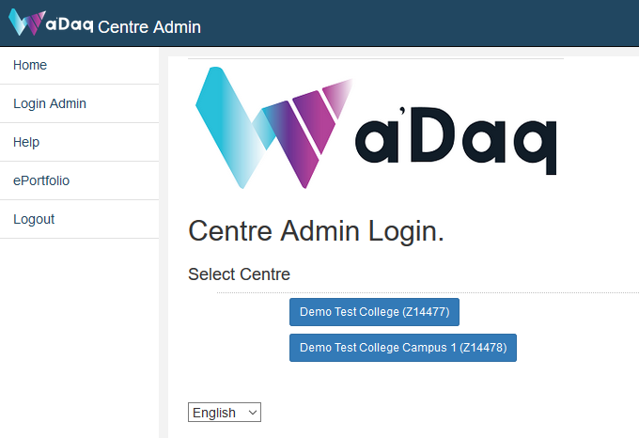

Select Role (Theory OnScreen).

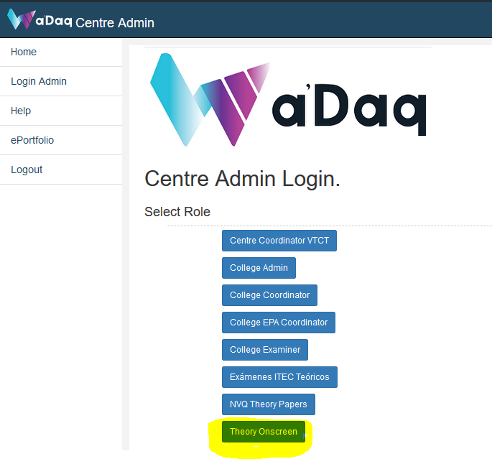

Theory exam onscreen can be started by Qualification, Unit, Booking and Student Search
Select from theory exam onscreen Menu options
Link to Theory Onscreen Menu is also available on Left, for small screens menu appears on top.
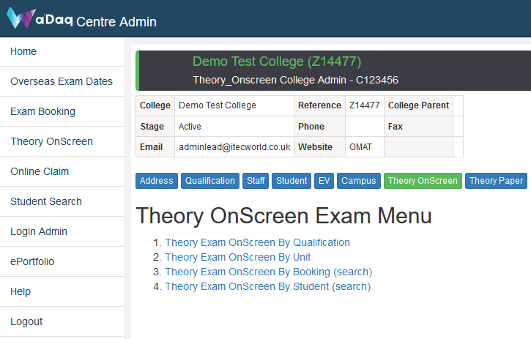

Option: Theory Exam OnScreen by Booking (search)
If the booking is OnScreen, System will display OnScreen Exam link.
Click OnScreen Exam link

Booking qualifications list
Click on Unit button link next to qualification name.
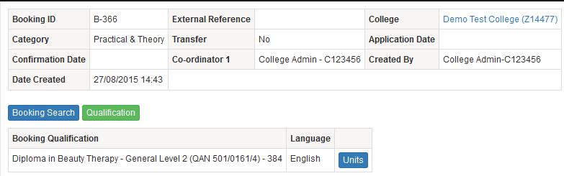
System will list the theory online exam available for students.
Click on Theory Exam link to launch OnScreen Exam for Student.
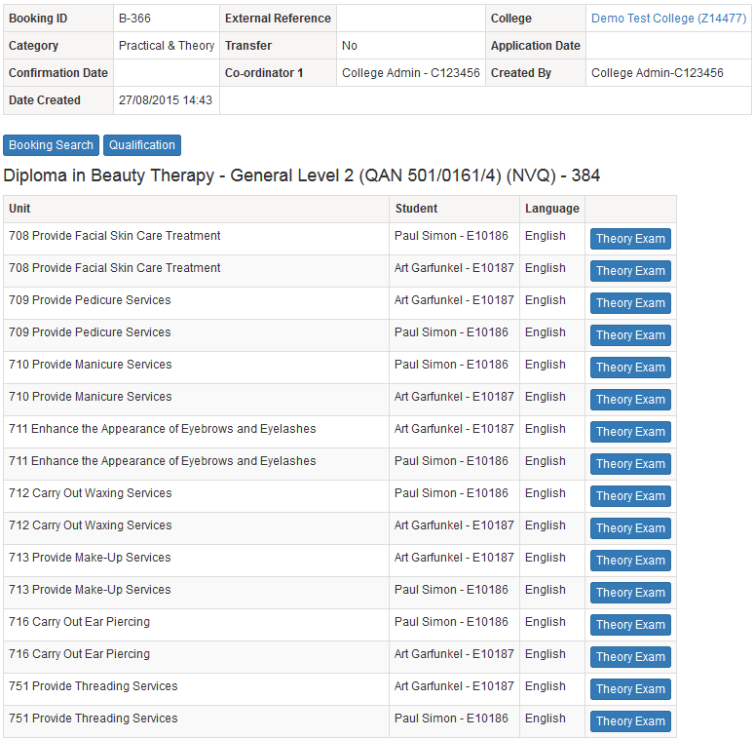

Verify Student exam details and click confirm.
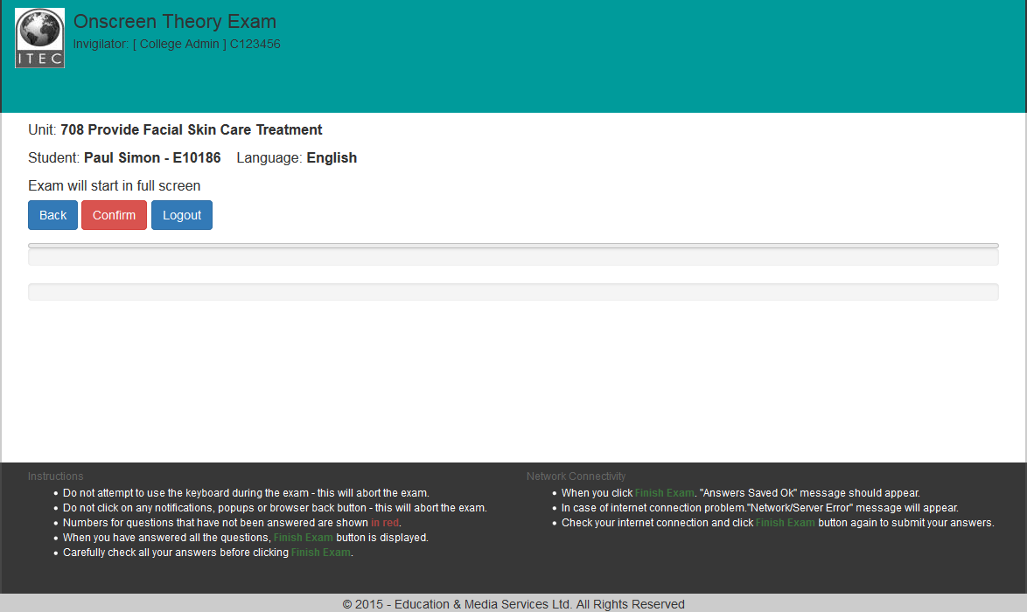

Read the instructions and click Start Exam
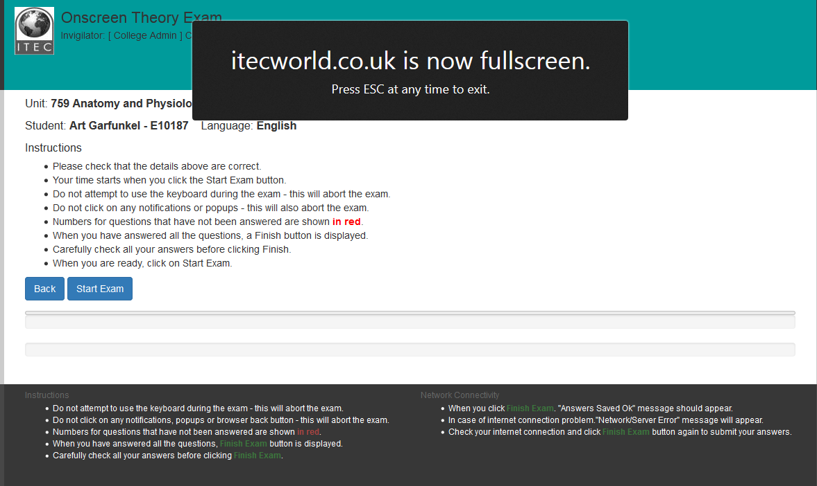

Answer the questions. Select from Option A, B, C, D
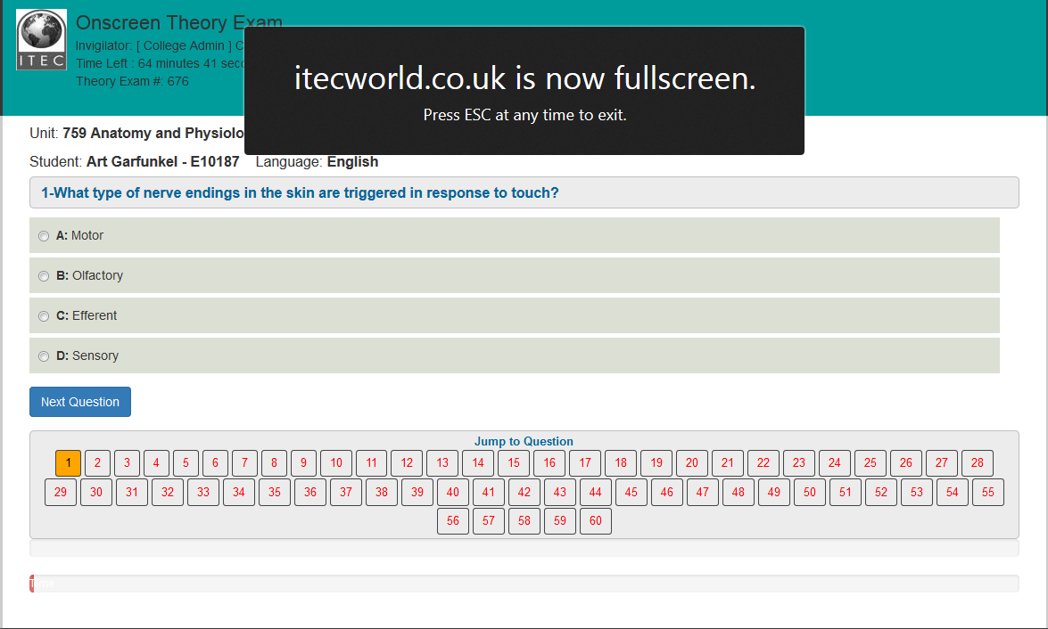

System will show the progress according to number of questions answered and time left.
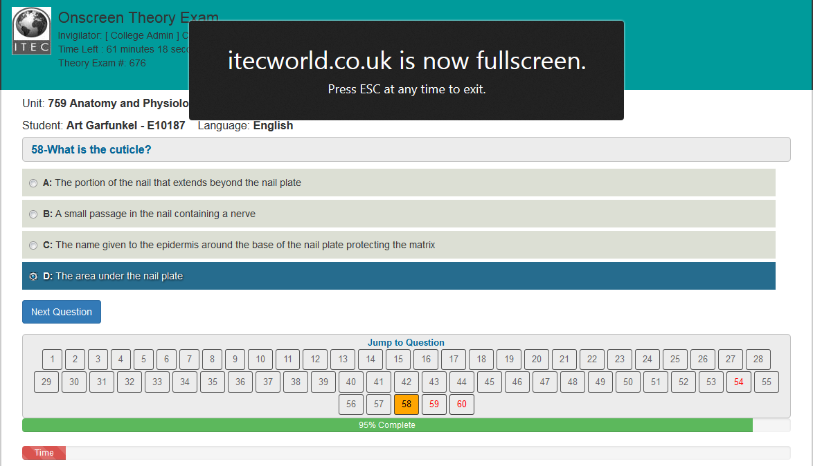

Once all the questions are answered system will show Finish Exam button.
Review your answers or click on Finish Exam
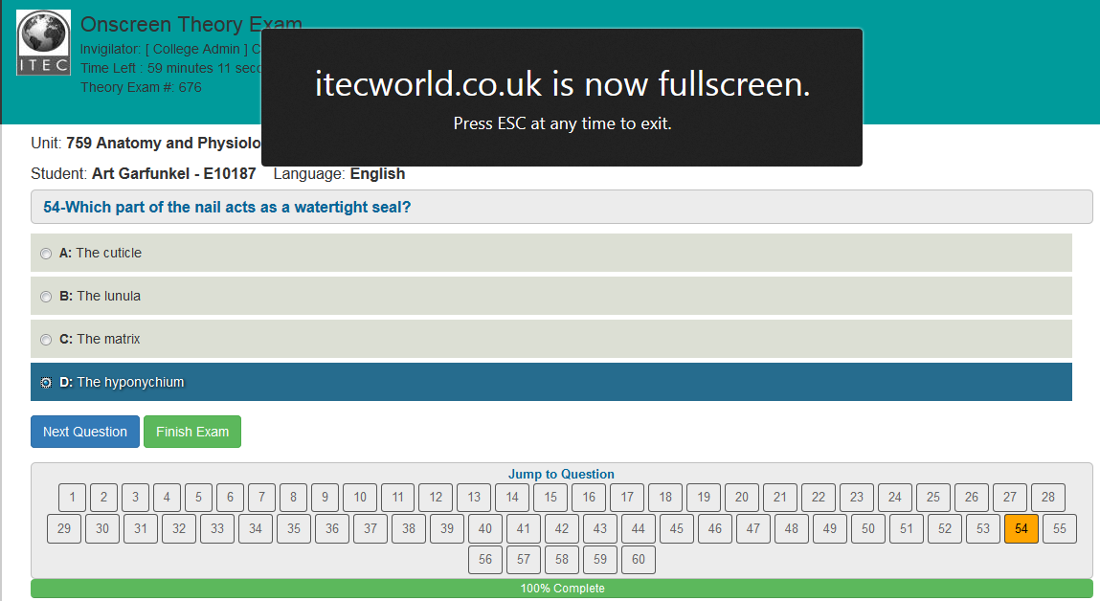
Depending on Unit Type NVQ or VRQ system will display message.
Click Continue,
Click Back to select next student from the list.
Click Logout to end exam session.

