Client Consultation Form – Laser & Intense Pulsed

Light Treatments

College Name:
College Number:
Student Name:
Student Number:
Date:

Client Name:
Address:

Profession:
Tel. No: Day
Eve

PERSONAL DETAILS
Age group: Under 20 20–30 30–40 40–50 50–60 60+
Lifestyle: Active Sedentary
Last visit to the doctor:
GP Address:
No. of children (if applicable):
Date of last period (if applicable):

CONTRAINDICATIONS REQUIRING MEDICAL REFERRAL OR THE CLIENT TO INDEMNIFY THEIR CONDITION IN WRITING PRIOR TO TREATMENT (select if/where appropriate):

Any condition already being treated by a GP, dermatologist or another skin therapist
Medical oedema
Osteoporosis
Arthritis
Nervous/Psychotic conditions
Recent operations
Diabetes
Asthma
Bells Palsy
Trapped/Pinched nerve
Inflamed nerve
Acute rheumatism

CONTRAINDICATIONS THAT RESTRICT TREATMENT (select if/where appropriate):

Fever
Contagious or infectious diseases
Under the influence of drugs or alcohol
Cancer
Pregnancy
Drugs or medications that cause photo-sensitisation or skin thinning effects
Herbal remedies that cause photo-sensitisation
Allergies to the products or materials used
Epilepsy
Cardio-vascular conditions (thrombosis, phlebitis, hypertension, hypotension, heart conditions)
Connective tissue disorders (scleroderma)
Herpes
Skin diseases
Undiagnosed lumps and bumps
Cuts
Bruises
Abrasions
Sunburn
Suntanned skin
Artificial tan until the product has faded from the skin
Areas of undiagnosed pain
Skin pigment conditions (vitiligo, melasma moles and pigmented naevi)
Keloid scars
Any metal pins or plates
Loss of skin sensitivity (test with tactile and thermal methods)

TREATMENT:

Hair removal
Skin Rejuvenation
Pigmentation
Diffused redness

SUN EXPOSURE IN THE LAST 30 DAYS: YES NO

PATCH TEST: Date: Area:

PATCH TEST REACTION:

MEDICAL HISTORY:

AREA TO BE TREATED (select if/where appropriate):
Face:

Upper lip
Chin
Cheeks
Neck
Side Burns
Hairline
Jaw line

Body:

Underarms
Bikini line
Shoulders
Upper arms
Chest
Forearms
Back
Buttocks
Thighs
Lower leg
Abdomen
Hands

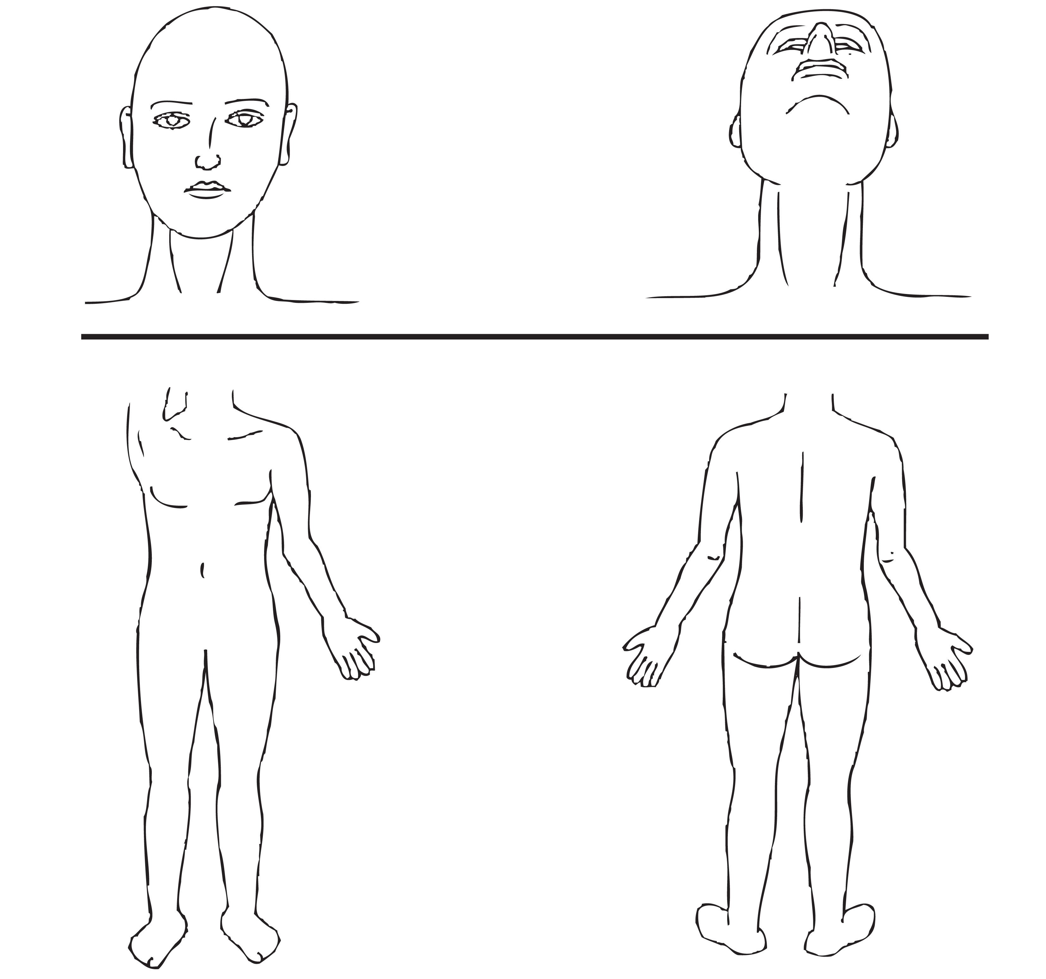
PREVIOUS TREATMENT (select if/where appropriate):

Waxing
Threading
Tweezing
Depilatory cream
Bleaching
Shaving
Epilation
Sugaring
Cosmetic surgery
Micro pigmentation
Microdermabrasion

Date of previous treatment:

Any reaction to previous treatment: YES NO
If yes please state reaction:

SKIN TYPE:

I
II
III
& Ethnic Skins

SKIN TYPE DETAILS:

SKIN CONDITION:

Pigmentation
Area:
Skin rejuvenation
Area:
Diffused redness
Area:

HAIR CONDITION:

Hirsutism
Hypertrichosis
Superfluous hair

Informed Consent: YES NO

Photographic evidence: YES NO

Treatment details(to include skin cooling method and parameters):

Reaction during treatment:

Client feedback:

Aftercare and Home care advice:

Therapist signature……………………………………

Client signature…………………………………………

Date…………………..

