

Clinical Case Study Form
UBT279 – Provide Ultrasound Treatments

Centre name:
Centre number:
Learner name:
Learner number:
Date:

Client name:
Address:
Profession:
Telephone number: | Day:
Telephone number: | Evening:

Personal details:
Age group: | Under 20 ☐ | 20 – 30 ☐ | 30 – 40 ☐ | 40 – 50 ☐ | 50 – 60 ☐ | 60+ ☐
Occupation:
Lifestyle: | Active ☐ |  |  | Sedentary ☐
Details of activity:
GP Address:

Contra-indications that prevent treatment – (Select if/where appropriate):
Active infection – bacterial, viral, fungal, herpetic | ☐ | Active inflammation | ☐ | Anticoagulant medication | ☐
Autoimmune conditions | ☐ | Cancer | ☐ | Contagious skin diseases | ☐
Degenerative  neurological disorders | ☐ | Diabetes | ☐ | Diseases stimulated by heat | ☐
Dysfunctions of the  nervous system | ☐ | Epilepsy | ☐ | Heart disease/disorder | ☐
Hepatitis | ☐ | Herpes Simplex | ☐ | Inflammations/infection in treatment area | ☐
Injections in treatment area | ☐ | Internal defibrillator | ☐ | Impaired kidney function | ☐
Impaired liver function | ☐ | IVF procedure | ☐ | Lactation | ☐
Metal implants in treatment area (excluding dental implants) | ☐ | Osteoporosis | ☐ | Pacemaker | ☐
Pregnancy | ☐ | Recent pregnancy | ☐ | Renal failure | ☐
Silicone implants in  treatment area | ☐ | Swelling in treatment area | ☐ | Thrombosis | ☐
Thrombophlebitis | ☐ | Thyroid disorders | ☐ | Transplant surgery | ☐
Under the influence of excessive alcohol | ☐ | Undiagnosed lumps | ☐ | Varicose veins | ☐
Comments:

Contra-indications that restrict treatment – (Select if/where appropriate):
Within treatment area:
Abrasions | ☐ | Bruises | ☐ | Cuts | ☐
Epilation treatment | ☐ | IPL treatment | ☐ | Laser treatment | ☐
Large moles | ☐ | Metal prostheses/implants | ☐ | Prior to cosmetic surgery | ☐
Loss of skin sensitivity | ☐ | Recent UV exposure | ☐ | Scarification of the skin | ☐
Sensitive/reactive skin type | ☐ | Tattoos in impact zone | ☐ | Varicose veins | ☐
Comments:

General:
Active inflammatory dermatoses | ☐ | Anxiety | ☐ | Body piercings | ☐
Bruises | ☐ | Circulatory disorders | ☐ | Current medications | ☐
Facial laser resurfacing | ☐ | Fresh scars/wounds | ☐ | Herbal remedies | ☐
Implants/IUDs (specific to device used | ☐ | Ongoing isotretinoin use | ☐ | Poor mental/emotional state | ☐
Recent dermal filler injections | ☐ | Recent surgical procedures | ☐ | Scars | ☐
Supplements | ☐
Comments:

Written permission required by:
Either of which should be attached to the treatment form
GP/Specialist ☐ | Informed consent ☐

Personal information – (Select if/where appropriate):
Have you had any health problems in the past or present?
If yes, please specify: | Yes ☐ | No ☐
Have you been under the care of a medical practitioner or other healthcare specialist in the last year?
If yes, please specify: | Yes ☐ | No ☐
Are you currently using any prescription medications (oral or topical)?
If yes, please specify: | Yes ☐ | No ☐
Are you currently using any supplements or herbal remedies (oral or topical)?
If yes, please specify: | Yes ☐ | No ☐

Do you suffer from anxiety, stress, depression and/or are clinically diagnosed?
If yes, please specify: |  |  |  |  | Yes ☐ | No ☐
What are your stress levels?  1 to 10 (10 being the highest) |  |  |  |  | At work: | At home:
Do you smoke?
If yes, how many per day? |  |  |  |  | Yes ☐ | No ☐
Do you drink alcohol?
If yes, how many units per week? |  |  |  |  | Yes ☐ | No ☐
Are you trying to conceive, pregnant or lactating?
If yes, please specify: |  |  |  |  | Yes ☐ | No ☐
Are you:
Due or having your  menstrual period | ☐ | Peri-menopausal | ☐ | Menopausal |  |  | ☐
Additional details:

Do you have any allergies?
If yes, please provide details: | Yes ☐ | No ☐
What is your level of sun exposure?
Please specify details:
Are you currently sun/wind burnt? | Yes ☐ | No ☐
Do you wear a sun protectant?
If yes, please specify SPF/frequency of application: | Yes ☐ | No ☐
Do you suffer from Herpes simplex?
If yes, please specify where outbreaks occur/frequency: | Yes ☐ | No ☐

Have you had any of the following within the last 14 days?
Depilatory treatments | Yes ☐ | No ☐ | Laser | Yes ☐ | No ☐
Electrolysis | Yes ☐ | No ☐ | Microdermabrasion | Yes ☐ | No ☐
IPL | Yes ☐ | No ☐ | Skin needling | Yes ☐ | No ☐
Light based therapy | Yes ☐ | No ☐ | Skin peeling | Yes ☐ | No ☐
If yes, please specify treatment details (to include treatment dates, frequency, results and client satisfaction with outcome):

Do you use Retin A or any other prescription skin care products?
If yes, please specify details: |  |  |  |  | Yes ☐ | No ☐
Have you taken/used Isotretinoin within the last 6-12 months?
If yes, please specify details: |  |  |  |  | Yes ☐ | No ☐
Do you use home care products containing any of the following?
Exfoliating granules | ☐ | Glycolic Acid | ☐ | Lactic Acid |  |  | ☐
Other Alpha Hydroxy Acids | ☐ | Vitamin A derivatives (Retinol) | ☐
If yes, please specify skin reaction after use:
What is your current daily skincare regime, including product details?
Morning:
Evening:
What specific body concerns do you have?
What are your expectations of this treatment?

Skin assessment:
Skin type: | Normal | ☐ | Combination |  | ☐ | Dry | ☐
Skin type: | Oily | ☐
Skin condition:
Skin sensitivity: | Reactive | ☐ | Impaired barrier |  | ☐ | Unresponsive | ☐
Skin thickness: | Thin | ☐ | Medium |  | ☐ | Thick | ☐
Epidermal  thickness: | Thin | ☐ | Medium |  | ☐ | Thick | ☐
Surface hydration levels:
Pigmentation details:
Skin texture:
Additional comments:
Skin sensitivity patch test: – (Documentary evidence of patch test to be included) | Date:
 | Area(s) tested:
 | Thermal test: |  | Positive |  | ☐ | Negative | ☐
 | Tactile test: |  | Positive |  | ☐ | Negative | ☐
 | Additional comments:
Treatment objectives: | Fat removal/inch loss | ☐ | Treatment of cellulite |  | ☐
Treatment objectives: | Please specify details:
Area(s) to be treated: –  (detail where appropriate) | 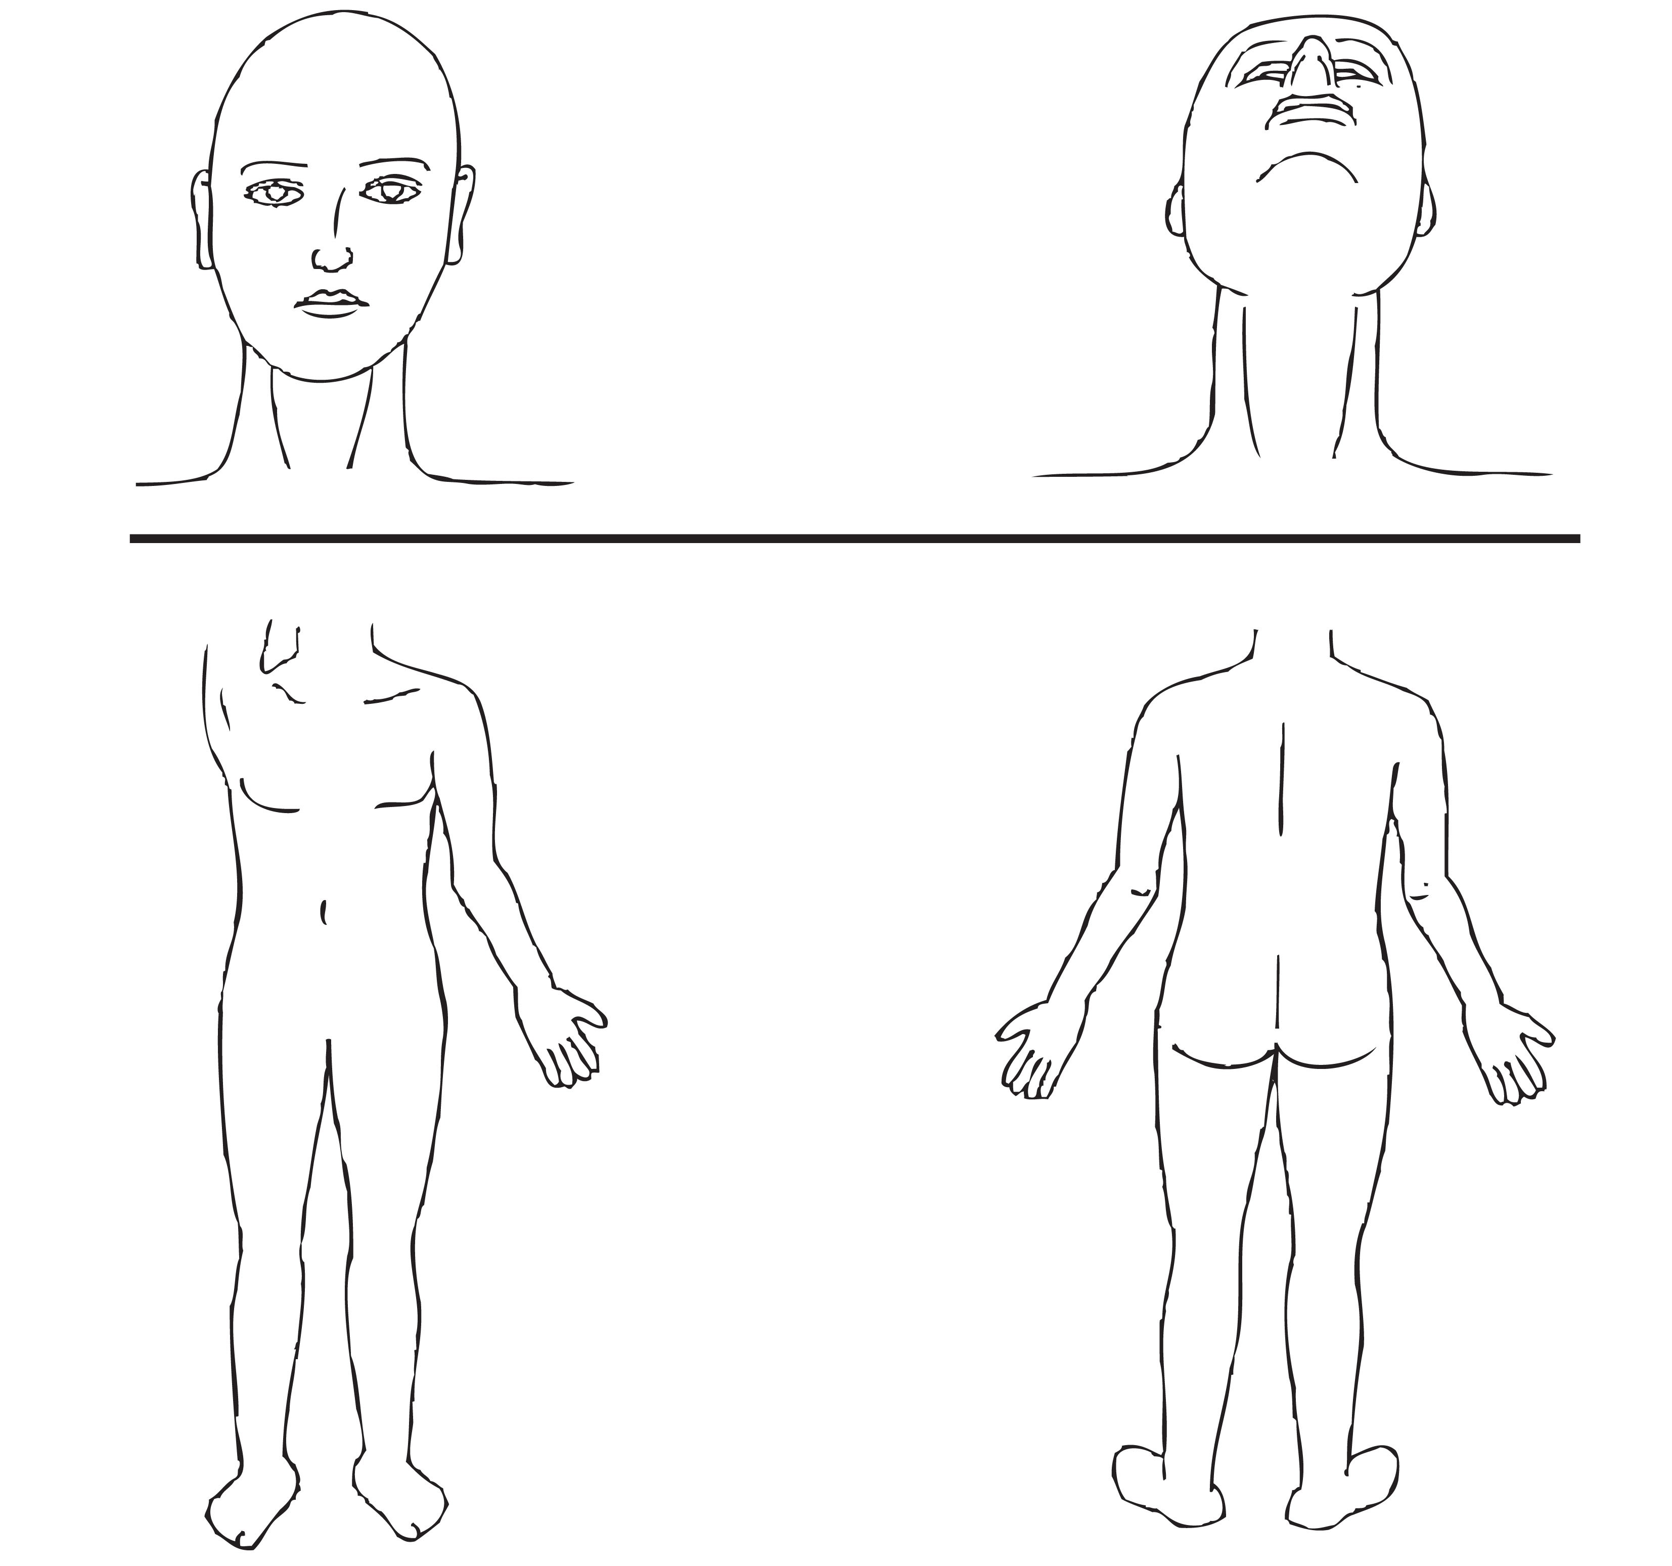
Area(s) to be treated: –  (detail where appropriate) | Cellulite deposits:
Area(s) to be treated: –  (detail where appropriate) | Fat deposits: | Hard fat |  | ☐ | Soft fat |  | ☐
Area(s) to be treated: –  (detail where appropriate) | Body contour:
Area(s) to be treated: –  (detail where appropriate) | Skin laxity:
Pre-treatment photograph taken: | Yes | ☐ | No |  | ☐
Comments:

Treatment details – (including client reaction to treatment and treatment parameters):
Areas treated:
Current intensity:
Duration of current flow:
Areas requiring modification:
Reaction levels:
Skin reaction to treatment:
Post-treatment photograph taken: | Yes | ☐ | No | ☐
Client feedback:
Post care/Home care advice given:
Comments:

Pre-treatment consent and treatment information
The ultrasound treatment is designed to reduce fat deposits and improve body contours. During the treatment you may experience a ‘ringing’ in your ears, a gradual warming sensation on the skin and your skin may turn red. This will fade following treatment but you should tell your advanced non-medical aesthetic practitioner about the sensations you experience during treatment.

Immediately following treatment your skin may feel slightly sensitive. You may also experience mild erythema (redness) or bruises may develop within one or two days.

Your active involvement before, during and after the treatment will establish the treatment outcome. It is vital that you adhere to the pre-treatment regime and homecare protocols as instructed by your advanced non-medical aesthetic practitioner.

Client Name ___________________________________________________________________________________

Please initial those that apply:
_______ I have provided accurate medical information and consultation details to my advanced non-medical aesthetic practitioner.

________ I am not pregnant or lactating.

________ I do not have any active Herpes simplex (cold sores). Prophylactic antiviral medication or topical antiviral cream may be used up 2 days before treatment and up to 3 days after treatment.

________ I agree not to receive needling treatments on the treatment area 1 weeks prior to treatment.

________ I agree not to receive any of the following on the treatment area 2 weeks prior to treatment – bleaching, electrolysis, depilation, skin treatments using AHA/BHA/Vitamin A, Hair colouring, IPL/Laser for skin rejuvenation, IPL/Laser for hair removal, light therapy, microdermabrasion.

________ I agree to avoid the use of any prescribed topical medications i.e. Retin A, Salicylic Acid a minimum of 2 weeks prior to treatment.

________ I agree to avoid the use of active skin/body care 3-5 days prior to treatment.

________ I confirm that I have not used Isotretinoin in the past 6 months.

________ I agree to follow the treatment protocol advised by my advanced non-medical aesthetic practitioner prior to treatment.

________ I agree to avoid direct UV exposure 24 hours before treatment.

________ I agree to avoid alcohol for 24 hours before treatment.

________ I agree to avoid eating a heavy meal 2 hours before treatment.

________ I agree to avoid caffeinated drinks 2 hours before treatment.

________ I agree to increase my water consumption to 1.5-2 litres per day before treatment.

________ I agree to notify my advanced non-medical aesthetic practitioner of any concerns.

________ I understand that the following contra-actions may occur:
- Allergic reaction | - Bruising | - Erythema (redness)
- Excessive oedema

_______ I understand that thermal/tactile tests must be performed in order to ascertain my levels of sensitivity.

_______ I understand that treatment results are varied and not guaranteed.

_______ I have discussed my expectations and goals with my advanced non-medical aesthetic practitioner.

_______ I have discussed the treatment limitations and possible complications with my advanced non-medical aesthetic practitioner.

_______ I acknowledge the possibility of an adverse reaction to treatment and take sole responsibility for any medical care that may become necessary. I agree to immediately inform the practitioner performing the treatment of any adverse effects.

_______ My advanced non-medical aesthetic practitioner has provided treatment information and answered all of the questions I have concerning this treatment.

_______ I fully understand all of the above information.

Client name: ____________________________________________________________________________________

Client signature: _________________________________________________________________________________

Advanced non-medical aesthetic practitioner name: ____________________________________________________

Advanced non-medical aesthetic practitioner signature: _________________________________________________

Date: ______________________________

Photographs of the treatment area(s) are taken before, during and after treatment to monitor and document progress.
I hereby authorise _____________________________ to take photographs of me before, during and after my treatment series.
Client signature: _______________________________ Date: ___________________

Photographs are useful tools for educating others about conditions such as your own.
I hereby authorise __________________________ to use or show my photographs for the purpose of education.
Client signature: ____________________________ Date: ______________________

Post-treatment instructions
In order to achieve the best results possible it is important that you read and understand the following instructions. Your advanced non-medical aesthetic practitioner will discuss the required post-treatment protocols with you following treatment; these instructions must be adhered to as advised by your advanced non-medical aesthetic practitioner.
- Your advanced non-medical aesthetic practitioner will advise you of the expected treatment recovery time and skin response.
- Avoid consuming alcohol for 24 hours following treatment.
- Avoid eating a heavy meal for 2 hours after the treatment.
- Avoid drinks containing caffeine for 2 hours following treatment.
- Increase water intake to at least 2 litres per day.
- Avoid additional heat treatments such as saunas, steam rooms, sun beds etc. for 24 hours as excess heat can lead to discomfort, inflammation and irritation.
- Avoid direct sun exposure for 48 hours following treatment.
- Avoid strenuous/excessive exercise for 24 hours to prevent overheating/increased blood circulation.
- Avoid the use of glycolic acid, retinol, AHA/BHA products for at least 24 hours.
- Use post-treatment products as instructed by your advanced non-medical aesthetic practitioner.
- Your advanced non-medical aesthetic practitioner will advise you of ongoing lifestyle and treatment recommendations and suitable treatments which may be used in conjunction with ultrasound cavitation treatment.

Additional information:

I accept the results of the treatment performed today and I understand and agree to adhere to the above instructions. I agree to contact my advanced non-medical aesthetic practitioner with any additional questions I may have.

Client name: ______________________________________________________________________________

Client signature: __________________________________________ Date: ____________________________

Advanced non-medical aesthetic practitioner name: ______________________________________________

Advanced non-medical aesthetic practitioner signature: _____________________ Date: ________________

Lecturer name: ____________________________________________________________________________

Lecturer signature: __________________________________________ Date: __________________________

Skin Sensitivity/Patch Test

Client information
Please read carefully and only sign if you are in full agreement with its contents.

I _____________________ confirm that I have received the required skin sensitivity/patch test(s) 24-48 prior to ultrasound cavitation treatment and confirm that I am willing to proceed.

You should note that if the learner is unable to explain to you the treatment contra-actions and contra-indications or is unsure of anything that may apply to a specific condition then they should not treat you without asking you to consult with your GP or Consultant.

It is your responsibility and not that of the learner to consult your GP or Consultant.

I hereby indemnify the learner against any adverse reaction sustained as a result of the treatment.

Client signature: _____________________________________ Date: _____________________

Learner signature: ____________________________________ Date: _____________________

