

Clinical Case Study Form
UBT276 – Remove or Fade Tattoos using Q Switched Laser Systems

Centre name:
Centre number:
Learner name:
Learner number:
Date:

Client name:
Address:
Profession:
Telephone number: | Day:
Telephone number: | Evening:

Personal details:
Age group: | Under 20 ☐ | 20 – 30 ☐ | 30 – 40 ☐ | 40 – 50 ☐ | 50 – 60 ☐ | 60+ ☐
Occupation:
Lifestyle: | Active ☐ |  |  | Sedentary ☐
Details of activity:
GP Address:

Contra-indications that prevent treatment – (Select if/where appropriate):
Antibiotics  i.e. Minocyline | ☐ | Anti-arrhythmic drugs  i.e. Amiodorone | ☐ | Gold medications | ☐
Herbal remedies  i.e. St John’s Wort | ☐ | HIV | ☐ | Inappropriate tattoo pigment type/colour | ☐
Keloid scarring | ☐ | Kidney disease | ☐ | Lupus | ☐
Lymphatic disorders | ☐ | Melanoma | ☐ | Eyeliner Micropigmentation | ☐
Oral/topical retinoids | ☐ | Oral/topical steroids | ☐ | Oral/topical medication – photo-dynamic therapy | ☐
Photo-sensitising medication (not all) | ☐ | Pregnancy | ☐ | Pigmentary disorders  i.e Melasma | ☐
Tanned skin/fake tan | ☐ | Uncontrolled diabetes | ☐ | UV tattoos | ☐
Comments:

Contra-indications that restrict treatment – (Select if/where appropriate):
Acne | ☐ | Aspirin medication | ☐ | Diabetes | ☐
Eczema | ☐ | Epilepsy | ☐ | Infectious/contagious diseases | ☐
Non-melanoma skin cancers | ☐ | Skin diseases/disorders | ☐
Comments:

Written permission required by:
Either of which should be attached to the treatment form
GP/Specialist ☐ | Informed consent ☐

Personal information – (Select if/where appropriate):
Have you had any health problems in the past or present?
If yes, please specify: | Yes ☐ | No ☐
Have you been under the care of a medical practitioner or other healthcare specialist in the last year?
If yes, please specify: | Yes ☐ | No ☐
Are you currently using any prescription medications (oral or topical)?
If yes, please specify: | Yes ☐ | No ☐
Are you currently using any supplements or herbal remedies (oral or topical)?
If yes, please specify: | Yes ☐ | No ☐
Do you suffer from anxiety, stress, depression and/or clinically diagnosed?
If yes, please specify: | Yes ☐ | No ☐
What are your stress levels?  1 to 10 (10 being the highest) | At work: | At home:
Do you smoke?
If yes, how many per day? | Yes ☐ | No ☐
Do you drink alcohol?
If yes, how many units per week? | Yes ☐ | No ☐

Are you trying to conceive, pregnant or lactating?
If yes, please specify: |  |  |  |  | Yes ☐ | No ☐
Are you:
Due or having your  menstrual period | ☐ | Peri-menopausal | ☐ | Menopausal |  |  | ☐
Additional details:

Do you have any allergies?
If yes, please provide details: | Yes ☐ | No ☐
What is your level of sun exposure/UV tolerance?
Please specify details:
Are you currently sun/wind burnt? | Yes ☐ | No ☐
Do you wear a sun protectant?
If yes, please specify SPF/frequency of application: | Yes ☐ | No ☐
Do you suffer from Herpes simplex?
If yes, please specify where outbreaks occur/frequency: | Yes ☐ | No ☐

Have you had any of the following within the last 14 days?
Tattoo removal – chemical extraction | Yes ☐ | No ☐ | Facial surgery | Yes ☐ | No ☐
Tattoo removal – ablative lasers | Yes ☐ | No ☐ | IPL | Yes ☐ | No ☐
Tattoo removal – salabrasion | Yes ☐ | No ☐ | Light based therapy | Yes ☐ | No ☐
Tattoo cover-up treatment | Yes ☐ | No ☐ | Laser | Yes ☐ | No ☐
Botox/injectable dermal fillers | Yes ☐ | No ☐ | Microdermabrasion | Yes ☐ | No ☐
Depilatory treatments | Yes ☐ | No ☐ | Skin needling | Yes ☐ | No ☐
Electrolysis | Yes ☐ | No ☐ | Skin peeling | Yes ☐ | No ☐
If yes, please specify treatment details (to include treatment dates, frequency, results and client satisfaction with outcome):

Do you use Retin A or any other prescription skin care products?
If yes, please specify details: | Yes ☐ | No ☐
Have you used Isotretinoin within the last 6-12 months?
If yes, please specify details: | Yes ☐ | No ☐
What are your expectations of this treatment?

Skin Assessment
Skin type: | Fitzpatrick scale I | ☐ | Fitzpatrick scale II |  | Fitzpatrick scale III | ☐
Skin type: | Fitzpatrick scale IV | ☐ | Fitzpatrick scale V | ☐ | Fitzpatrick scale VI | ☐
Skin type: | Level of pigmentation:
Skin sensitivity: | Reactive | ☐ | Impaired barrier | ☐ | Unresponsive | ☐
Skin healing capacity: | Brown pigmentation | ☐ | Pink/fades to white | ☐
Skin thickness: | Thin | ☐ | Medium | ☐ | Thick | ☐
Skin thickness: | Additional comments:
Patch test: (Documentary evidence of patch test to be included | Date:
 | Area(s) tested:
 | Patch test reaction: |  | Positive | ☐ | Negative | ☐
 | Additional comments:
Treatment objectives: | Tattoo removal | ☐ | Tattoo fading | ☐
Treatment objectives: | Please specify details:

Area to be treated: | Body site:
Area to be treated: | Age of tattoo:
Area to be treated: | Size of tattoo:
Area to be treated: | Design complexity – colours:
Area to be treated: | Ink density: |  | Light | ☐ | Moderate | ☐
Area to be treated: |  |  | Heavy | ☐
Area to be treated: | Type of tattoo: |  | Professional | ☐ | Amateur | ☐
Area to be treated: |  |  | Medicinal | ☐ | Cosmetic | ☐
Area to be treated: |  |  | Semi-permanent | ☐ | Traumatic | ☐
Area to be treated: | Pigment type/colours:
Area to be treated: | Smoking status:
Area to be treated: | Other:
Area to be treated: | 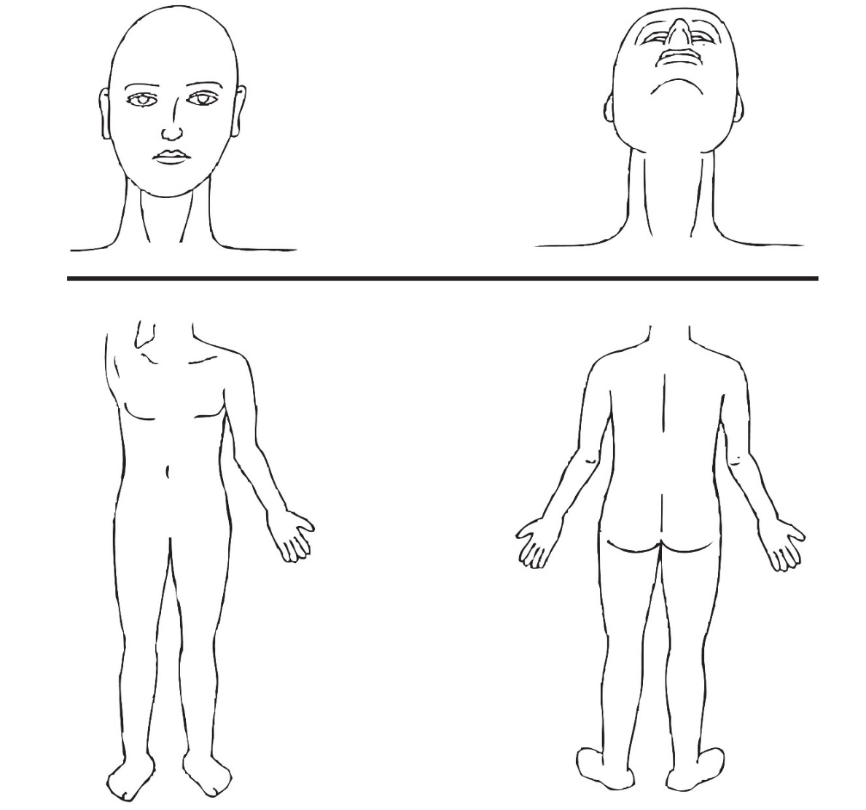
Area to be treated: | Please specify details:
Pre-treatment photographs taken: | Yes | ☐ | No | ☐
Additional comments:

Treatment details – (including client reaction to treatment and treatment parameters):
Pre-treatment preparations:
Equipment selection: | Ruby | ☐ | Alexandrite |  | ☐ | Nd:YAG |  | ☐
Equipment selection: | KTP frequency  doubled Nd: YAG | ☐
Equipment selection: | Additional comments:
Treatment parameters:
Wavelength used:
Duration of treatment:
Endpoints: | Erythema | ☐ | Petechiae |  | ☐ | Oedema |  | ☐
Endpoints: | Whitening | ☐ | Audible click |  | ☐
Endpoints: | Additional comments:
Post-treatment procedures:
Post-treatment photograph taken: | Yes | ☐ |  | No | ☐
Client feedback:
Post-care/
Homecare advise given:
Additional comments:

Pre-treatment consent and treatment information
The laser tattoo removal or fading treatment is designed to reduce or remove tattoos. During the treatment you may experience some discomfort like a rubber band snapped on the skin or a rapid succession of pricks to the skin depending on your own personal threshold. This will fade following treatment but you should tell your practitioner about the sensations you experience during treatment.

Pin point bleeding may occur during treatment. Immediately following treatment your skin may feel dry and tight, with minor swelling and petechiae. You may also experience erythema (redness), and moderate flaking while the skin is healing. The skin may crust / scab up and not flake. Blistering may also develop later the same day or in the day following treatment.

Your active involvement before, during and after the treatment will establish the treatment outcome. It is vital that you adhere to the pre-treatment skincare regime and homecare protocols as instructed by your advanced non-medical aesthetic practitioner.

Client name: ___________________________________________________________________________________

Please initial those that apply:
_______ I have provided accurate medical information and consultation details to my advanced non-medical aesthetic practitioner.

_______ I am not pregnant or lactating.

_______ I do not have any active Herpes simplex (cold sores). Prophylactic antiviral medication or topical antiviral cream may be used up to 2 days before treatment and up to 3 days after treatment.

_______ I agree to not receive any of the following on the treatment area 2 weeks prior to treatment – Botox, injectable dermal fillers or needling treatments.

_______ I agree not to receive any of the following on the treatment area 2 weeks prior to treatment – bleaching, electrolysis, depilation, facial treatments using AHA/BHA/Vitamin A, hair colouring, IPL/Laser for skin rejuvenation, IPL/Laser for hair removal, light therapy, microdermabrasion.

_______ I agree to avoid the use of any prescribed topical medications i.e. Retin A, Salicylic Acid a minimum of 2 weeks prior to treatment.

_______ I agree to avoid the use of active skin care 3-5 days prior to treatment.

_______ I confirm that I have not used Isotretinoin in the past 6 months.

_______ I agree to follow the treatment protocol advised by my advanced non-medical aesthetic practitioner prior to treatment.

_______ I agree to avoid direct sun exposure.

_______ I agree to apply a sunscreen daily (minimum SPF30).

_______ I agree to avoid any heat treatment immediately prior to treatment.

_______ I agree to notify my advanced non-medical aesthetic practitioner of any concerns.

_______ I understand that the following contra-actions may occur:
- Blistering | - Oedema | - Scarring
- Erythema (redness) | - Petechiae | - Urticaria
- Excessive discomfort whilst healing | - Pin point bleeding | - Temporary whitening of the skin
- Infection | - Pigmentary changes

_______ I understand that a patch test must be performed to determine skin reaction and treatment parameters. I understand that a new patch test must be carried out where differing types/colours (change) of pigment occur.

_______ I understand that treatment results are varied and not guaranteed.

_______ I have discussed my expectations and goals with my advanced non-medical aesthetic practitioner.

_______ I have discussed the treatment limitations and possible complications with my advanced non-medical aesthetic practitioner.

_______ I acknowledge the possibility of an adverse reaction to treatment and take sole responsibility for any medical care that may become necessary. I agree to immediately inform the practitioner performing the treatment of any adverse effects.

_______ My advanced non-medical aesthetic practitioner had provided treatment information and answered all of the questions I have concerning this treatment.

_______ I fully understand all of the above information.

Client name: ____________________________________________________________________________________

Client signature: _________________________________________________________________________________

Advanced non-medical aesthetic practitioner name: ____________________________________________________

Advanced non-medical aesthetic practitioner signature: _________________________________________________

Date: ______________________________

Photographs of your skin are taken before, during and after treatment to monitor and document progress.
I hereby authorise _____________________________ to take photographs of me before, during and after my treatment series.
Client signature: _______________________________ Date: ___________________

Photographs are useful tools for educating others about conditions such as your own.
I hereby authorise __________________________ to use or show my photographs for the purpose of education.
Client signature: ____________________________ Date: ______________________

Post-treatment instructions
In order to achieve the best results possible it is important that you read and understand the following instructions. Your advanced non-medical aesthetic practitioner will discuss the required post treatment protocols with you following treatment; these instructions must be adhered to as advised by your advanced non-medical aesthetic practitioner.
- Your advanced non-medical aesthetic practitioner will advise you of the expected treatment recovery time and skin response.
- Crust/scabs may appear on the treated area and these seal the skin and prevent infection. The skin could feel dry, tight and itchy – DO NOT RUB OR PICK the skin during the healing process.
- Avoid touching the treated area and only pat dry – DO NOT RUB.
- Bruising may become apparent and should resolve within 7-12 days of treatment.
- Use only products advised by the advanced non-medical aesthetic practitioner to avoid premature removal of healing crusts/scabs.
- Avoid activities which may dislodge/soften healing crusts/scabs or irritate the skin such as swimming, saunas, steam rooms, hot baths and perfumed products for 24-48 hours following treatment.
- Avoid direct sun exposure during the healing process – approximately 4 weeks.
- Make-up should not be applied whilst the skin is healing.
- If skin is broken or blistering appears, your advanced non-medical aesthetic practitioner will apply a suitable dressing to prevent infection. All perfumed products/cosmetics should be avoided until the skin has healed.
- Use post-treatment products as instructed by your advanced non-medical aesthetic practitioner.
- If infection occurs, seek medical attention immediately.
- Your advanced non-medical aesthetic practitioner will advise you of ongoing treatment recommendations.

Additional information:

I accept the results of the treatment performed today and I understand and agree to adhere to the above instructions. I agree to contact my advanced non-medical aesthetic practitioner with any additional questions I may have.
Client name: _______________________________________________________________________________

Client signature: __________________________________________ Date: _____________________________

Advanced non-medical aesthetic practitioner name: _______________________________________________

Advanced non-medical aesthetic practitioner signature: ____________________________________________

Lecturer name: _____________________________________________________________________________

Lecturer signature: __________________________________________________________________________

Patch Test

Client information
Please read carefully and only sign if you are in full agreement with its contents.

I _____________________ confirm that I have received the required patch test(s) a minimum of one week prior to tattoo fading or removal treatment and confirm that I am willing to proceed.

You should note that if the learner is unable to explain to you the treatment contra-actions and contra-indications or is unsure of anything that may apply to a specific condition then they should not treat you without asking you to consult with your GP or Consultant.

It is your responsibility and not that of the learner to consult your GP or Consultant.

I hereby indemnify the learner against any adverse reaction sustained as a result of the treatment.

Client signature: _____________________________________ Date: _____________________

Learner signature: ___________________________________ Date: _____________________

