

Treatment Evidence Form

iUSP151 – Conducting subjective and objective assessment
Centre name:
Centre number:
Learner name:
Learner number:
Date:

Client name:
Address:
Profession:
Telephone number: | Day:
Telephone number: | Evening:

Personal details:
Age group: | Under 20 ☐ | 20 – 30 ☐ | 30 – 40 ☐ | 40 – 50 ☐ | 50 – 60 ☐ | 60+ ☐
Lifestyle: | Active ☐ |  |  | Sedentary ☐
Last visit to the doctor:
GP address:
Number of children:
(If applicable)
Date of last period:
(If applicable)

Contra-indications requiring medical permission – in circumstances where medical permission cannot be obtained clients must give their informed consent in writing prior to treatment (Select if/where appropriate):
Pregnancy | ☐ | Epilepsy | ☐ | Cancer | ☐
Cardiovascular conditions (thrombosis, phlebitis, hypertension, hypotension, heart conditions) | ☐ | Recent operations | ☐ | Postural deformities | ☐
Haemophilia | ☐ | Diabetes | ☐ | Spastic conditions | ☐
Any condition already being treated by a GP or another health professional, e.g., Physiotherapist, Osteopath, Chiropractor, Coach | ☐ | Any dysfunction of the nervous system (e.g., Muscular sclerosis, Parkinson’s disease, Motor neurone disease) | ☐ | Kidney infections | ☐
Medical oedema | ☐ | Bell’s palsy | ☐ | Whiplash | ☐
Osteoporosis | ☐ | Trapped/Pinched nerve (e.g., sciatica) | ☐ | Slipped disc | ☐
Arthritis | ☐ | Inflamed nerve | ☐ | Undiagnosed pain | ☐
When taking prescribed medication | ☐ | Acute rheumatism | ☐ | Nervous/psychotic conditions | ☐

Contra-indications that restrict treatment (Select if/where appropriate):
Fever | ☐ | Varicose veins | ☐ | Sunburn | ☐
Contagious or infectious diseases | ☐ | Pregnancy (abdomen) | ☐ | Hormonal implants | ☐
Under the influence of recreational drugs or alcohol | ☐ | Cuts | ☐ | Abdomen (first few days of menstruation depending how the client feels) | ☐
Diarrhoea and vomiting | ☐ | Bruises | ☐ | Haematoma | ☐
Skin diseases | ☐ | Varicose veins | ☐ | Hernia | ☐
Undiagnosed lumps and bumps | ☐ | Abrasions | ☐ | Recent fractures (minimum 3 months) | ☐
Localised swelling | ☐ | Scar tissue (2 years for major operation and 6 months for a small scar) | ☐ | Cervical spondylitis | ☐
Gastric ulcers | ☐ | After a heavy meal | ☐ | Inflammation | ☐

Written permission required by(either of which should be attached to the consultation form):–
GP/specialist ☐ | Informed consent ☐

Personal information (Select if/where appropriate):
Muscular/skeletal problems: | Back | ☐ | Aches/pain |  | ☐ | Stiff joints |  |  | ☐ | Headaches | ☐
Digestive problems: | Constipation | ☐ | Bloating |  | ☐ | Liver/gall bladder |  |  | ☐ | Stomach | ☐
Circulation: | Heart | ☐ | Blood pressure |  | ☐ | Fluid retention |  |  | ☐ | Tired legs | ☐
Circulation: | Varicose veins | ☐ | Cellulite |  | ☐ | Kidney problems |  |  | ☐ | Cold hands and feet | ☐
Gynaecological: | Irregular periods | ☐ | P.M.T |  | ☐ | Menopause |  |  | ☐ | H.R.T | ☐
Gynaecological: | Pill | ☐ | Coil |  | ☐ | Other |  |  |  |  | ☐
Nervous system: | Migraine | ☐ | Tension |  | ☐ | Stress |  |  | ☐ | Depression | ☐
Immune system: | Prone to infections |  | ☐ | Sore throats |  |  | ☐ | Colds |  |  | ☐
Immune system: | Sinuses |  |  |  | ☐ | Chest |  |  |  |  | ☐
Current medical condition/  Treatment | Pain nature onset | ☐ | Duration |  | ☐ | Daily pain pattern:
Current medical condition/  Treatment | Aggravates sitting | ☐ | Standing |  | ☐ | Walking |  |  | ☐ | Running | ☐

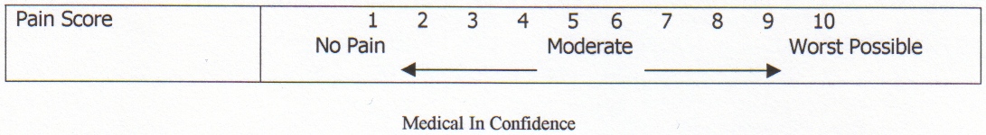
History of present condition (select if/where appropriate):
Recurring injury | Yes |  |  |  |  |  |  |  |  |  | ☐ | No |  |  |  |  |  |  |  |  |  | ☐
What treatment was undertaken?
How long did the injury take to heal?
Did you have any investigations? | Yes |  |  | ☐ | No |  |  |  |  |  | ☐ | If yes, which ones:
Regular  antibiotic/  medication taken? | Yes |  |  | ☐ | No |  |  |  |  |  | ☐ | If yes, which ones:
Herbal remedies taken? | Yes |  |  | ☐ | No |  |  |  |  |  | ☐ | If yes, which ones:
Ability to relax: | Good |  |  |  |  | ☐ |  | Moderate |  |  |  |  |  |  | ☐ |  | Poor |  |  |  |  | ☐
Sleep patterns: | Good |  |  | ☐ | Poor |  |  |  |  |  | ☐ | Average no. of hours
Do you see natural daylight in your workplace? | Yes |  |  |  |  |  |  |  |  |  | ☐ | No |  |  |  |  |  |  |  |  |  | ☐
Do you work at a computer? | Yes |  |  | ☐ | No |  |  |  |  |  | ☐ | If yes, how many hours
Do you eat regular meals? | Yes |  |  |  |  |  |  |  |  |  | ☐ | No |  |  |  |  |  |  |  |  |  | ☐
Do you eat in a hurry? | Yes |  |  |  |  |  |  |  |  |  | ☐ | No |  |  |  |  |  |  |  |  |  | ☐
Do you take any food/vitamin supplements? | Yes |  |  | ☐ | No |  |  |  |  |  | ☐ | If so, which ones?
How many portions of each of these items does your diet contain per day? | Fresh fruit: |  |  |  | Fresh vegetables: |  |  |  |  |  |  | Protein and source:
 | Dairy produce: |  |  |  | Sweet things: |  |  |  |  |  |  | Added salt: |  |  |  |  |  |  |  | Added sugar:
How many units of these drinks do you consume per day? | Tea: |  |  |  | Coffee: |  |  |  |  |  |  | Fruit juice: |  |  |  |  |  |  |  | Water:
How many units of these drinks do you consume per day? | Soft drinks: |  |  |  | Others:
Do you suffer from food allergies? | Yes |  |  |  |  |  |  |  |  |  | ☐ | No |  |  |  |  |  |  |  |  |  | ☐
Bingeing? | Yes |  |  |  |  |  |  |  |  |  | ☐ | No |  |  |  |  |  |  |  |  |  | ☐
Overeating? | Yes |  |  |  |  |  |  |  |  |  | ☐ | No |  |  |  |  |  |  |  |  |  | ☐
Do you smoke? | Yes |  |  |  |  |  |  | ☐ |  | No |  |  |  |  |  | ☐ |  | How many a day?
Do you drink alcohol? | Yes |  |  |  |  |  |  | ☐ |  | No |  |  |  |  |  | ☐ |  | How many units a day?
Do you exercise? | None |  |  | ☐ | Occasional |  |  |  |  |  | ☐ | Irregular |  |  |  |  |  |  | ☐ | Regular |  | ☐
Do you exercise? | Types:
What is your skin type? | Dry | ☐ | Oily |  |  |  | ☐ |  | Combination |  |  |  | ☐ | Sensitive |  |  |  |  |  | ☐ | Dehydrated | ☐
Do you suffer/have you suffered from | Dermatitis |  |  | ☐ | Acne |  |  |  |  |  | ☐ | Eczema |  |  |  |  |  |  | ☐ | Psoriasis |  | ☐
Do you suffer/have you suffered from | Allergies |  |  | ☐ | Hay Fever |  |  |  |  |  | ☐ | Asthma |  |  |  |  |  |  | ☐ | Skin cancer |  | ☐
Stress level 1–10 (10 being the highest): | At work |  |  |  |  |  |  |  |  |  | ☐ | At home |  |  |  |  |  |  |  |  |  | ☐

Physical examination:
Observations:
Head:
Shoulders:
Back:
Pelvis:
Legs:
Feet:
Body alignment/
posture:
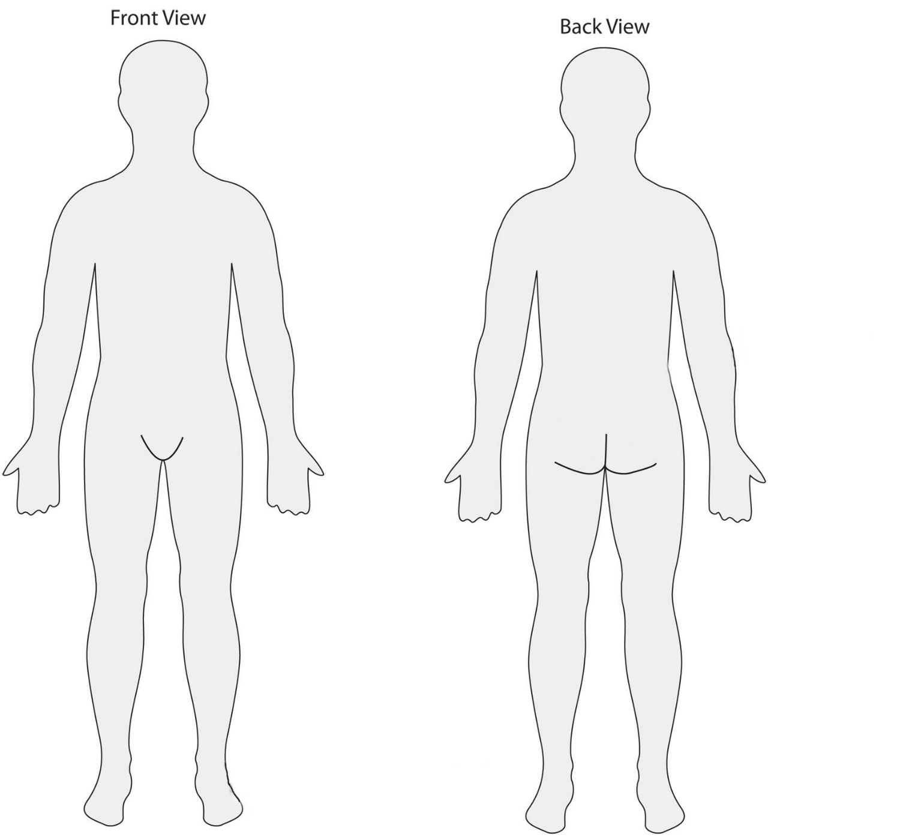
Assessment:

To include:

Palpations:

Joint movement tested: to include spinal range and movement of the upper and lower limbs
Joint/active/passive ROM | Right | Left | Joint Active / Passive ROM | Right | Left

Muscle tests – Isometric strength testing:
Muscle group | Right | Left
Muscle length tests
Muscle bulk

Special tests:
Test | Right | Left | Comments

Functional tests:

Range of movement findings, identifying strengths and areas for improvement:

Pre-existing conditions/disease processes (therapeutic and remedial):

Devise treatment plan and state rationale for chosen massage interventions:

Learner signature: _______________________________________________________________________________

Client signature: _________________________________________________________________________________

Document History
Version | Issue Date | Changes | Role
v1 | 27/09/2019 | First published | Qualifications Administrator

