

Client Consultation/Assessment Evidence Form
iUSP158 – Conduct complex assessment for sports massage
Centre name:
Centre number:
Learner name:
Learner number:
Date:

Client name:
Address:
Profession:
Telephone number: | Day:
Telephone number: | Evening:

Personal details:
Age group: | Under 20 ☐ | 20 – 30 ☐ | 30 – 40 ☐ | 40 – 50 ☐ | 50 – 60 ☐ | 60+ ☐
Lifestyle: | Active ☐ |  |  | Sedentary ☐
Last visit to the doctor:
GP Address:
Number of children:
(If applicable)
Date of last period:
(If applicable)

Contra-indications requiring medical permission – in circumstances where medical permission cannot be obtained clients must give their informed consent in writing prior to treatment (Select if/where appropriate):
Pregnancy | ☐ | Recent operations | ☐ | Spastic conditions | ☐
Cardiovascular conditions (thrombosis, phlebitis, hypertension, hypotension, heart conditions) | ☐ | Diabetes | ☐ | Kidney infections | ☐
Haemophilia | ☐ | Asthma | ☐ | Whiplash | ☐
Any condition already being treated by a GP or another health professional e.g. physiotherapist, osteopath, chiropractor or coach | ☐ | Any dysfunction of the nervous system e.g. Multiple sclerosis, Parkinson’s disease, Motor neurone disease | ☐ | Slipped disc | ☐
Medical oedema | ☐ | Bell’s palsy | ☐ | Undiagnosed pain | ☐
Osteoporosis | ☐ | Trapped/pinched nerve e.g. sciatica | ☐ | When taking prescribed medication | ☐
Arthritis | ☐ | Inflamed nerve | ☐ | Acute rheumatism | ☐
Nervous/psychotic conditions | ☐ | Cancer | ☐ | Epilepsy | ☐
Postural deformities | ☐

Contra-indications that restrict treatment – (Select if/where appropriate):
Fever | ☐ | Varicose veins | ☐ | Abdomen (first few days of menstruation depending how the client feels) | ☐
Contagious or infectious diseases | ☐ | Pregnancy (abdomen) | ☐ | Haematoma | ☐
Under the influence of recreational drugs or alcohol | ☐ | Cuts | ☐ | Hernia | ☐
Diarrhoea and vomiting | ☐ | Bruises | ☐ | Recent fractures (minimum 3 months) | ☐
Skin diseases | ☐ | Abrasions | ☐ | Cervical spondylitis | ☐
Undiagnosed lumps and bumps | ☐ | Scar tissue (2 years for major operation and 6 months for a small scar) | ☐ | Gastric ulcers | ☐
Localised swelling | ☐ | Sunburn | ☐ | After a heavy meal | ☐
Inflammation | ☐ | Hormonal implants | ☐

Written permission required by GP/Specialist – Either of which should be attached to the treatment form (Select if/where appropriate):
Yes | ☐ | No | ☐

Personal information – (Select if/where appropriate):
Muscular/Skeletal problems: | Back | ☐ | Aches/pain | ☐ | Stiff joints | ☐ | Headaches | ☐
Digestive problems: | Constipation | ☐ | Bloating | ☐ | Liver/gall bladder | ☐ | Stomach | ☐
Circulation: | Heart | ☐ | Blood pressure | ☐ | Fluid retention | ☐ | Tired legs | ☐
Circulation: | Varicose veins | ☐ | Cellulite | ☐ | Kidney problems | ☐ | Cold hands and feet | ☐
Gynaecological: | Irregular periods | ☐ | P.M.T | ☐ | Menopause | ☐ | H.R.T | ☐
Gynaecological: | Pill | ☐ | Coil | ☐ | Other:
Are you pregnant or trying for a baby? | Yes |  |  | ☐ | No |  |  | ☐
Nervous system: | Migraine | ☐ | Tension | ☐ | Stress | ☐ | Depression | ☐
Immune system: | Prone to infections | ☐ | Sore throats | ☐ | Colds | ☐ | Chest | ☐
Immune system: | Sinuses | ☐

Current medical condition/treatment – (Select if/where appropriate):
Pain nature onset | ☐ |  | Duration |  |  |  | ☐ | Daily pain pattern:
Aggravates sitting |  |  |  | ☐ | Standing |  |  |  | ☐ | Walking |  |  | ☐ | Running | ☐
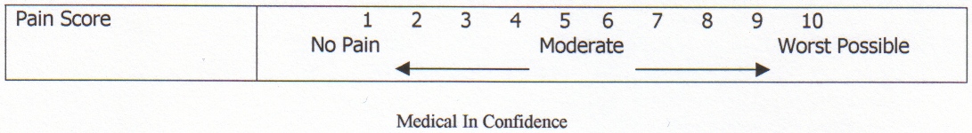

History of present condition
Recurring injury |  | Yes |  |  |  |  |  |  |  |  | ☐ | No |  |  | ☐
What treatment was undertaken?
How long did the injury take to heal?
Did you have any investigations? |  | Yes |  |  |  | ☐ | No |  |  |  | ☐ | If yes, which ones:

Regular antibiotic/medication taken?
If yes, which ones: |  |  |  |  |  |  | Yes ☐ |  | No ☐
Herbal remedies taken?
If yes, which ones: |  |  |  |  |  |  | Yes ☐ |  | No ☐
Ability to relax: | Good | ☐ | Moderate | ☐ | Poor | ☐
Sleep patterns: | Good | ☐ | Poor | ☐ | Average no. of hours:
Do you see natural daylight in your workplace? | Yes | ☐ | No | ☐
Do you work at a computer? | Yes | ☐ | No | ☐ | If yes, how many hours:
Do you eat regular meals? | Yes | ☐ | No | ☐
Do you eat in a hurry? | Yes | ☐ | No | ☐
Do you take any food/vitamin supplements? | Yes | ☐ | No | ☐ | If yes, which ones:
How many portions of each of these items does your diet contain per day? | Fresh fruit: |  | Fresh vegetables: |  | Protein and source:
 | Dairy produce: |  | Sweet things: |  | Added salt: |  |  | Added sugar:
How many units of these drinks do you consume per day? | Tea: |  | Coffee: |  | Fruit juice: |  |  | Water:
How many units of these drinks do you consume per day? | Soft drinks: |  | Others:
Do you suffer from food allergies? | Yes | ☐ | No | ☐
Do you smoke? | Yes | ☐ | No | ☐ | How many per day:
Do you drink alcohol? | Yes | ☐ | No | ☐ | How many units per day:
Do you exercise? | None | ☐ | Occasional | ☐ | Irregular | ☐ |  | Regular |  | ☐
Do you exercise? | Type:
What is your skin type? | Dry | ☐ | Oily | ☐ | Combination | ☐ |  | Dehydrated |  | ☐
Do you suffer/  have you suffered from: | Dermatitis | ☐ | Acne | ☐ | Eczema | ☐ |  | Psoriasis |  | ☐
Do you suffer/  have you suffered from: | Allergies | ☐ | Hay fever | ☐ | Asthma | ☐ |  | Skin cancer |  | ☐
Stress level:  1–10 (10 being the highest) | At work: |  | At home:

Physical examination:
Observations:
Head:
Shoulders:
Back:
Pelvis:
Legs:
Feet:
Body alignment/
posture:
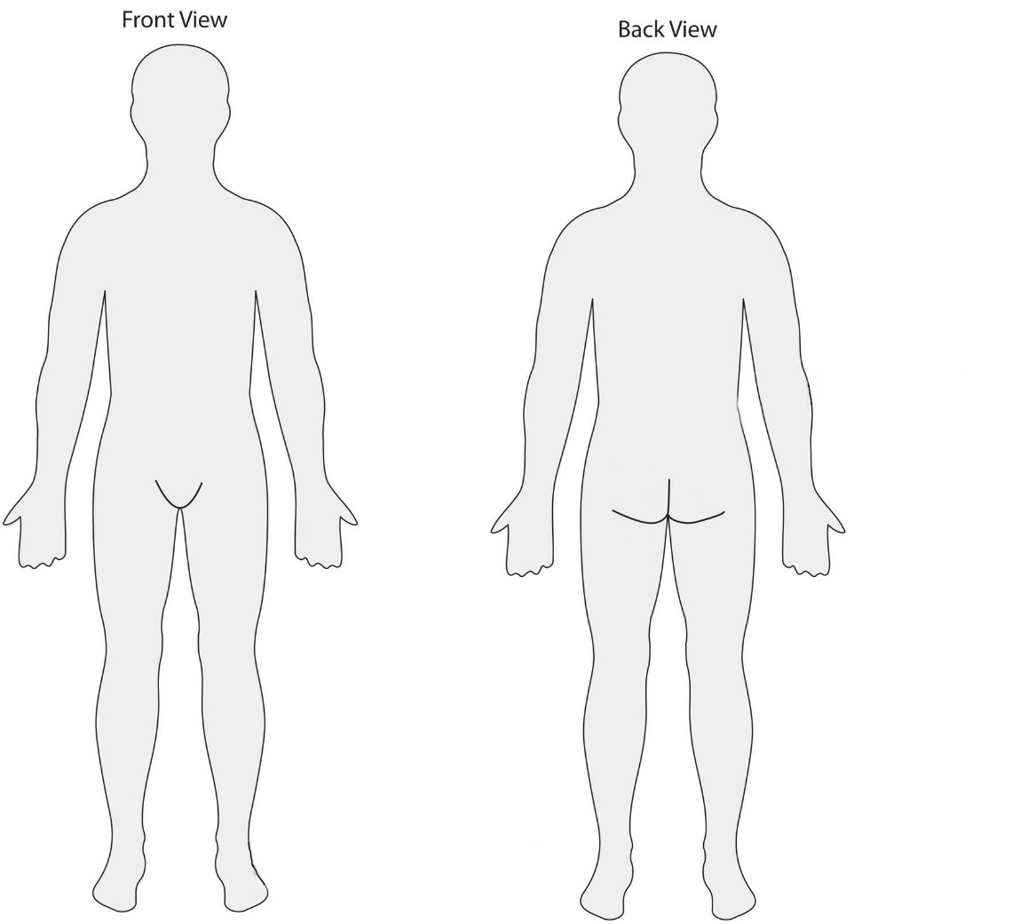

Assessment:
To include:
Palpations:

Joint movement tested: to include spinal range and movement of the upper and lower limbs
Joint/active/  passive ROM | Right | Left | Joint/active/  passive ROM | Right | Left

Muscle tests – isometric strength testing
Muscle group | Right | Left
Muscle length tests
Muscle bulk

Special tests – ligamentous and neural
Test | Right | Left | Comments

Functional tests:
Full postural analysis of symmetry and examination:
Gait analysis:
Range of movement findings, identifying strengths and areas for improvement:
Pre-existing conditions/disease processes: (therapeutic and remedial)
Devise treatment plan and massage strategies:
Rational for chose massage strategies:

Therapist/Learner signature: _______________________________________________________________________

Client signature: _________________________________________________________________________________

Document History
Version | Issue Date | Changes | Role
v1 | 03/09/2019 | First published | Qualifications and Regulation Co-ordinator

