

Treatment evidence form
iUBT326 – Laser and light treatments for hair removal
Centre name:
Centre number:
Learner name:
Learner number:
Date:

Client name:
Address:
Profession:
Telephone number: | Day:
Telephone number: | Evening:

Personal details:
Age group: | Under 20 ☐ | 20 – 30 ☐ | 30 – 40 ☐ | 40 – 50 ☐ | 50 – 60 ☐ | 60+ ☐
Lifestyle: | Active ☐ |  |  | Sedentary ☐
Last visit to the doctor:
GP Address:
Number of children:
(If applicable)
Date of last period:
(If applicable)

Contra-indications requiring medical permission – in circumstances where medical permission cannot be obtained clients must give their informed consent in writing prior to treatment (Select if/where appropriate):
Any condition already being treated by a GP or another complementary practitioner | ☐ | Diabetes | ☐ | Medical oedema | ☐
Asthma | ☐ | Bell’s palsy | ☐ | Osteoporosis | ☐
Trapped/pinched nerve  (e.g. sciatica) | ☐ | Arthritis | ☐ | Inflamed nerve | ☐
Nervous/psychotic conditions | ☐ | Acute rheumatism | ☐ | Recent operations | ☐
Undiagnosed skin lesions/dyschromia | ☐ | Other | ☐

Contra-indications that restrict treatment – (Select if/where appropriate):
Fever | ☐ | Contagious or infectious diseases | ☐ | Under the influence of drugs or alcohol | ☐
Cancer | ☐ | Pregnancy | ☐ | Drugs or medications that cause photo-sensitisation or skin thinning effects | ☐
Herbal remedies that cause photo-sensitisation | ☐ | Allergies to the products or materials used | ☐ | Epilepsy | ☐
Cardiovascular conditions (thrombosis, phlebitis, hypertension, hypotension, heart conditions) | ☐ | Connective tissue disorders (scleroderma) | ☐ | Herpes | ☐
Skin diseases | ☐ | Undiagnosed lumps and bumps | ☐ | Cuts | ☐
Bruises | ☐ | Abrasions | ☐ | Sunburn | ☐
Suntanned skin | ☐ | Artificial tan until the product has faded from the skin | ☐ | Areas of undiagnosed pain | ☐
Skin pigment conditions (vitiligo, melasma moles and pigmented naevi) | ☐ | Keloid scars | ☐ | Any metal pins or plates | ☐
Gold injections | ☐ | Skin types IV, V, VI | ☐ | Smoking within two hours of treatment | ☐
Smoking within two hours of treatment | ☐ | Loss of sensitivity | ☐ | Other | ☐

Sun exposure in the last 30 days: | Yes | ☐ | No | ☐

Goals and expectations of this treatment:

Patch Test:
Date: |  | Area:
Parameters used:
Patch test response:

Area to be treated – (Select if/where appropriate):
Face: | Upper lip | ☐ | Cheeks |  |  | ☐ | Side burns |  |  | ☐ | Jaw line | ☐
Face: | Chin | ☐ | Neck |  |  | ☐ | Hairline |  |  | ☐
Body: | Back | ☐ | Shoulders |  |  | ☐ | Underarms |  |  | ☐ | Upper arms | ☐
Body: | Forearms | ☐ | Hands |  |  | ☐ | Chest |  |  | ☐ | Abdomen | ☐
Body: | Buttocks | ☐ | Thighs/upper legs |  |  | ☐ | Lower legs |  |  | ☐
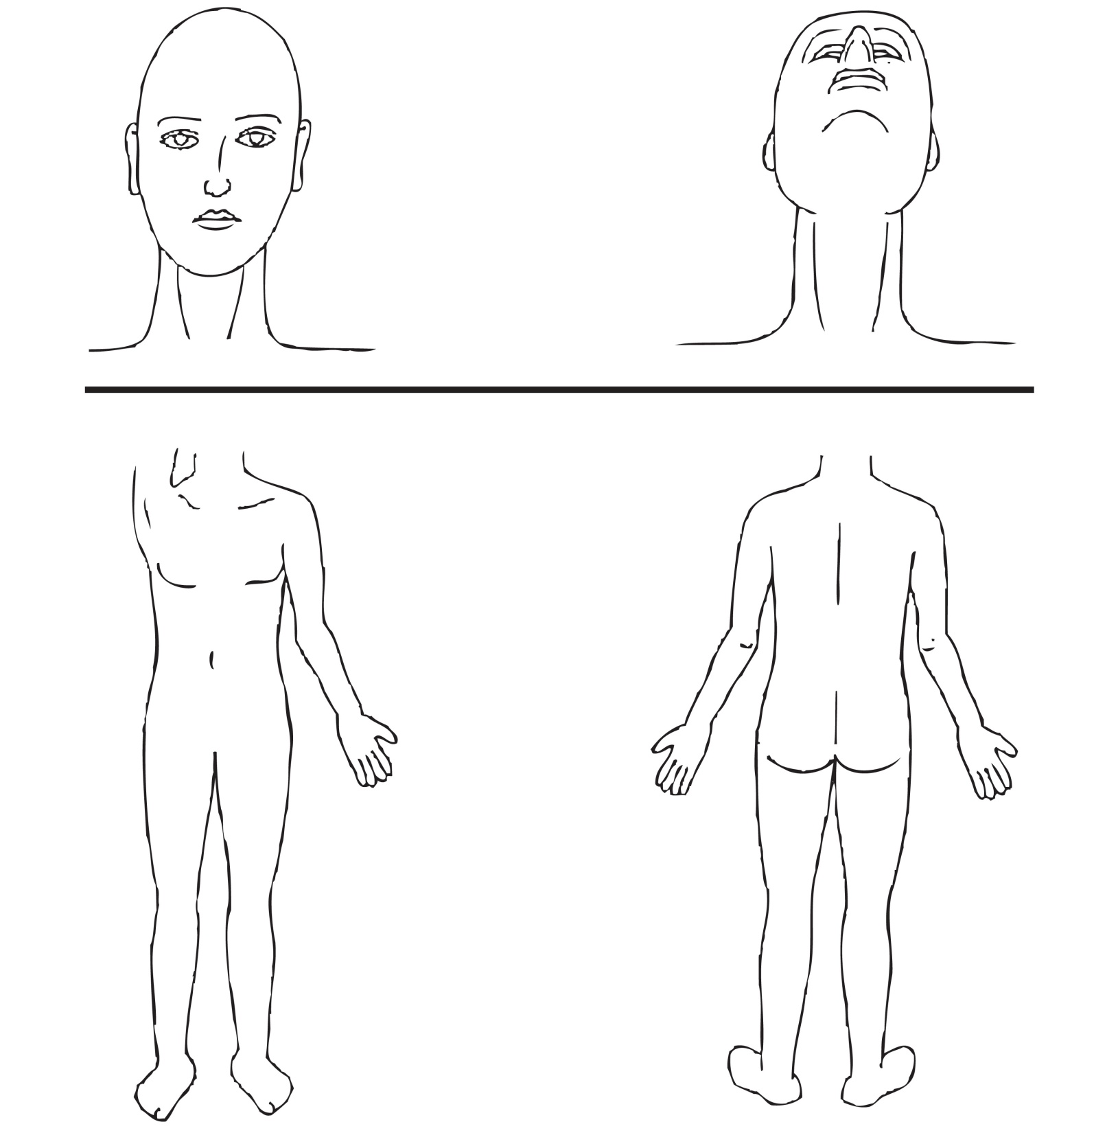
Previous treatment – (Select if/where appropriate):
Previous treatment: | Cosmetic surgery |  |  | ☐ | Micro pigmentation |  |  | ☐ | Microdermabrasion |  |  | ☐
Previous treatment: | Chemical peels |  |  | ☐ | Injectable treatments |  |  | ☐
Previous treatment: | Other:
Date of previous treatment:
Any reaction to previous treatment: | Yes |  |  |  |  | ☐ | No |  |  |  |  | ☐
If yes please state reaction:

Area to be treated – (Select if/where appropriate):
Skin phototypes: | I | ☐ | II | ☐ | III | ☐ | IV | ☐
Skin phototypes: | V | ☐ | VI | ☐
Hair/skin condition details:
Hair colour:
Hair thickness:
Hair density:
Type of hair: | Terminal | ☐ | Vellus | ☐
Informed consent: | Yes | ☐ | No | ☐
Photographic evidence: | Yes | ☐ | No | ☐

Treatment details – (including reaction to treatment and treatment parameters):

Type of equipment:

Wavelengths and depth of penetration:
Joules:
Pulse repetition rate:
Pulse duration:
Pulse delay:
Fluence:
Size of treatment beam (spot size):

Client feedback:

Aftercare and home care advice (including treatment interval and treatment monitoring):

Therapist/Learner signature: _______________________________________________________________________

Client signature: _________________________________________________________________________________

iUBT326 – Disclaimer

Please read carefully and only sign if you are in full agreement with its contents.

I ____________________ confirm that I have understood the treatment that I am to receive and confirm that I am willing to proceed without confirmation from my own GP or consultant.
OR
I ____________________ confirm that I have understood the treatment and given my medical history, I would prefer to consult with my GP or Consultant prior to receiving the treatment.

You should note that if the learner is unable to explain to you the treatment contra-actions and contra-indications or is unsure of anything that may apply to a specific condition then they should not treat you without asking you to consult with your GP or Consultant.

It is your responsibility and not that of the learner to consult your GP or Consultant.

I hereby indemnify the learner against any adverse reaction sustained as a result of the treatment.

Learner signature: ___________________________________________ Date: ____________________________

Client signature: _____________________________________________ Date: ____________________________

Document History
Version | Issue Date | Changes | Role
v1 | 03/12/2019 | First published | Qualifications Administrator

