

Treatment Evidence Form
iUBT407 – Laser and light treatments for skin rejuvenation

Centre name:
Centre number:
Learner name:
Learner number:
Date:

Client name:
Address:
Profession:
Telephone number: | Day:
Telephone number: | Evening:

Personal details:
Age group: | Under 20 ☐ | 20 – 30 ☐ | 30 – 40 ☐ | 40 – 50 ☐ | 50 – 60 ☐ | 60+ ☐
Lifestyle: | Active ☐ |  |  | Sedentary ☐
Last visit to the doctor:
GP Address:
Number of children:
(If applicable)
Date of last period:
(If applicable)

Contra-indications requiring medical referral or the client to indemnify their condition in writing prior to treatment (Select if/where appropriate):
Any condition already being treated by a GP, dermatologist or another skin therapist | ☐ | Medical oedema | ☐ | Osteoporosis | ☐
Arthritis | ☐ | Nervous/psychotic conditions | ☐ | Recent operations | ☐
Diabetes | ☐ | Asthma | ☐ | Bell’s palsy | ☐
Trapped/pinched nerve | ☐ | Inflamed nerve | ☐ | Acute rheumatism | ☐
Undiagnosed skin lesions | ☐ | Dyschromia in the treatment area | ☐ | Other:

Contra-indications that restrict treatment – (Select if/where appropriate):
Fever | ☐ | Contagious or infectious diseases | ☐ | Under the influence of drugs or alcohol | ☐
Cancer | ☐ | Pregnancy | ☐ | Drugs or medications that cause photo-sensitisation or skin thinning effects | ☐
Herbal remedies that cause photo-sensitisation | ☐ | Allergies to the products or materials used | ☐ | Epilepsy | ☐
Cardiovascular conditions (thrombosis, phlebitis, hypertension, hypotension, heart conditions) | ☐ | Connective tissue disorders (scleroderma) | ☐ | Herpes | ☐
Skin diseases | ☐ | Undiagnosed lumps and bumps | ☐ | Cuts | ☐
Bruises | ☐ | Abrasions | ☐ | Sunburn | ☐
Suntanned skin | ☐ | Artificial tan until the product has faded from the skin | ☐ | Areas of undiagnosed pain | ☐
Skin pigment conditions (vitiligo, melasma moles and pigmented naevi) | ☐ | Keloid scars | ☐ | Any metal pins or plates | ☐
Gold injections | ☐ | Skin types IV, V & VI | ☐ | Smoking within two hours of treatment (for diffused redness)
Loss of skin sensitivity (test with tactile and thermal methods) | ☐ | Other:

Treatment
Treatment: | Skin rejuvenation | ☐ | Pigmentation |  |  |  |  |  |  | ☐ | Diffused redness |  |  |  | ☐
Treatment: | Intrinsic ageing |  |  |  |  |  | ☐ |  | Extrinsic ageing |  |  |  | ☐
Sun exposure in the last 30 days: | Yes |  |  |  |  |  | ☐ |  | No |  |  | ☐
Goals and expectations of this treatment:
Patch test: | Date: |  |  |  |  |  |  | Area:
Patch test: | Parameters used: |  |  |  |  |  |  | Patch test response:
Area to be treated (face):  (select if/where appropriate) | Upper lip | ☐ | Cheeks |  |  |  |  |  |  | ☐ | Side burns |  |  |  | ☐
Area to be treated (face):  (select if/where appropriate) | Jaw line | ☐ | Chin |  |  |  |  |  |  | ☐ | Neck |  |  |  | ☐
Area to be treated (face):  (select if/where appropriate) | Hairline |  |  |  |  |  |  |  |  |  |  |  |  |  | ☐
Area to be treated (face):  (select if/where appropriate) | 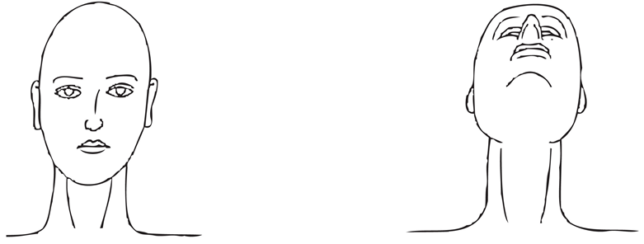
Area to be treated (body):  (select if/where appropriate) | Back | ☐ | Shoulders |  |  |  |  |  |  | ☐ | Underarms |  |  |  | ☐
Area to be treated (body):  (select if/where appropriate) | Upper arms | ☐ | Forearms |  |  |  |  |  |  | ☐ | Hands |  |  |  | ☐
Area to be treated (body):  (select if/where appropriate) | Chest | ☐ | Abdomen |  |  |  |  |  |  | ☐ | Buttocks |  |  |  | ☐
Area to be treated (body):  (select if/where appropriate) | Thighs/upper leg | ☐ | Lower leg |  |  |  |  |  |  | ☐
Area to be treated (body):  (select if/where appropriate) | 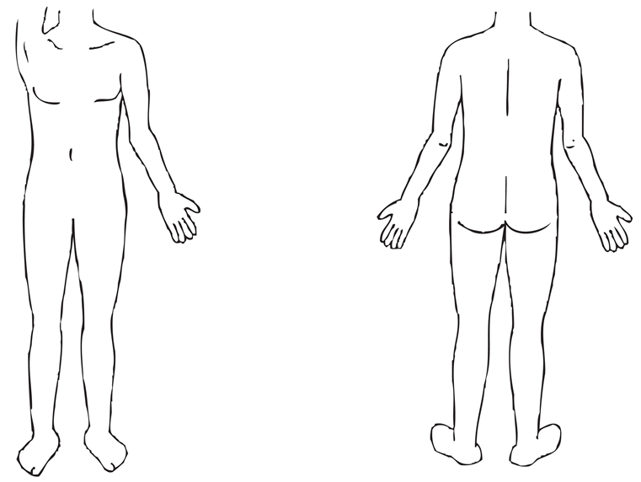
Previous treatment (select if/where appropriate): | Cosmetic surgery | ☐ | Micro pigmentation |  |  |  |  |  |  | ☐ | Microdermabrasion |  |  |  | ☐
Previous treatment (select if/where appropriate): | Chemical peels |  |  |  |  | ☐ |  |  | Injectable treatments |  |  |  |  | ☐
Previous treatment (select if/where appropriate): | Other:
Date of previous treatment:
Any reaction to previous treatment: | Yes |  |  |  | ☐ |  |  |  | No |  |  | ☐
If yes please state reaction:
Skin phototypes: | I | ☐ | II |  |  |  |  |  |  | ☐ | III |  |  |  | ☐
Skin phototypes: | IV | ☐ | V |  |  |  |  |  |  | ☐ | VI |  |  |  | ☐
Skin type details:
Skin condition: | Pigmentation |  |  | ☐ |  |  |  |  | Skin rejuvenation |  |  |  | ☐
Skin condition: | Area: |  |  |  |  |  |  |  | Area:
Skin condition: | Diffused redness |  |  |  | ☐ |  |  |  | Acne |  |  |  | ☐
Skin condition: | Area: |  |  |  |  |  |  |  | Area:
Informed consent: | Yes |  |  |  | ☐ |  |  |  | No |  |  | ☐
Photographic evidence: | Yes |  |  |  | ☐ |  |  |  | No |  |  | ☐

Treatment details – (including reaction to treatment and treatment parameters):

Client feedback:

Aftercare and home care advice – (including treatment interval and treatment monitoring):

Learner signature: _______________________________________________________________________________

Client signature: _________________________________________________________________________________

Sample Disclaimer
iUBT407 – Laser and Light Treatments for Skin Rejuvenation
Client Information

Please read carefully and only sign if you are in full agreement with its contents
I confirm that I have understood the treatment that I am to receive and confirm that I am willing to proceed without confirmation from my own GP or consultant.
OR
I confirm that I have understood the treatment and given my medical history, I would prefer to consult with my GP or consultant prior to receiving the treatment.
You should note that if the learner/therapist is unable to explain to you the contra-indications or is unsure of anything that may supply to a specific condition then they should not treat you without asking you to consult with your GP or consultant.

It is your responsibility and not that of the learner/therapist to consult your GP or consultant.
I hereby indemnify the learner/therapist against any adverse reaction sustained as a result of the treatment.

Learner signature: __________________________________________________ Date: _______________________

Client signature: ____________________________________________________Date: ______________________

Document History
Version | Issue Date | Changes | Role
v1 | 09/01/2020 | First published | Qualifications and Regulation Co-ordinator

